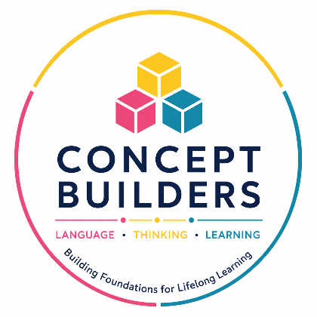

Subject: Referral Opportunity – Basic Concepts Cognitive Intervention Groups
Dear Colleague,
Many of the learners we work with experience barriers to learning not due to a lack of ability, but because the foundational skills required for learning are not yet firmly in place. Difficulties with conceptual language, limited vocabulary, and challenges understanding relationships such as size, position, sequence, and comparison can significantly impact a child’s ability to access the curriculum, follow instructions, and develop early literacy and numeracy skills.
To address these needs, we are offering Concept Builders, a structured, research-informed programme designed to strengthen the cognitive and language foundations essential for learning.
The programme is delivered in small groups and focuses on developing:
- Conceptual language and vocabulary
- Listening and attention skills
- Reasoning and problem-solving abilities
- Understanding of relationships (e.g. size, position, sequence, classification)
- Confidence in verbal expression
- Readiness for literacy and numeracy learning
The emphasis is on building thinking tools and conceptual understanding, enabling learners to engage more effectively with classroom demands.
Learners who may benefit include those who:
- Present with limited expressive language or restricted vocabulary
- Struggle to follow instructions or participate in classroom discussions
- Demonstrate weak conceptual understanding
- Experience early literacy or numeracy difficulties
- Show challenges with attention and self-regulation
- Appear capable but are not reaching their academic potential
The programme is particularly suited to Grade RR and Foundation Phase learners, as well as older children with developmental delays or identified learning barriers.
The intervention is based on the Basic Concepts Programme (BCP), which develops conceptual thinking through mediated learning experiences. Learners are supported in acquiring key cognitive processes such as comparison, classification, and seriation—skills that underpin learning across all areas of the curriculum.
Implementation is supported by the Basic Concepts Foundation (BCF), which provides:
- Learner screening and appropriate group placement
- Monitoring of learner progress
- Programme evaluation and feedback
We welcome referrals from professionals who feel their learners would benefit from this targeted, cognitively focused intervention.
If you would like to discuss a learner, request screening, or learn more about the programme, please feel free to get in touch.
Warm regards,
Dr Louis Benjamin and Ms Aimee Chiat

www.basicconcepts.co.za
Email: aimee.chiat@gmail.com


Mobile: +2781 479 3814

