Early Impact of the Basic Concepts Programme on
Conceptual Readiness in Metro East Focus Schools (March 2026)

Introduction
Developing strong conceptual language and thinking skills in the early years of schooling is widely recognised as a critical foundation for later learning in literacy and numeracy. Many learners entering formal schooling, particularly in under-resourced contexts, lack the conceptual vocabulary and cognitive structures required to access classroom instruction effectively. This gap often contributes to persistent learning difficulties in the early grades.
The Basic Concepts Programme (BCP) addresses this challenge by systematically mediating foundational concepts that underpin early learning. Drawing on principles of Mediated Learning Experience (MLE) developed by Reuven Feuerstein, the programme emphasises intentional teaching of conceptual relationships such as size, position, classification, and quantity. Through structured mediation and guided interaction, learners develop the conceptual frameworks that support problem-solving, language development, and academic learning.
The Metro East Education District (MEED) Focus Schools Project was established to implement the BCP in selected schools while simultaneously building teacher capacity through training, mentoring, and classroom support. The present brief reports on the early impact of the programme on learners’ conceptual knowledge, measured through a comparison of Grade 1 learner cohorts before and after programme implementation.

Methodology
Study Design
The evaluation employed a quasi-experimental cohort comparison design. A baseline group of Grade 1 learners was assessed in 2025 before the Basic Concepts Programme had been introduced. Following teacher training and classroom implementation of the programme during the 2025 Grade R year, a new cohort of Grade 1 learners was assessed in early 2026.
This design allows comparison of learner outcomes before and after programme implementation within the same schools.
Participants and Sampling
A random sample of 64 Grade 1 learners was assessed at baseline in March 2025. The sample included 16 learners from each of four participating schools in the Metro East district.
Following one year of programme implementation in Grade R classrooms, a new random sample of 64 Grade 1 learners from the same schools was assessed in early 2026.
Intervention
During 2025, teachers from the participating schools received training in the Basic Concepts Programme, which focuses on developing learners’ conceptual understanding through mediated classroom interactions. Teachers implemented the programme with their Grade R learners throughout the school year, supported by mentoring and classroom visits.
Assessment Instrument
Learners were assessed using the Test of Basic Concepts Knowledge, which measures understanding of key conceptual domains:
- Colour
- Shape
- Size
- Position
- Number
- Letter
The assessment produces a total score ranging from 0 to 24, reflecting overall conceptual knowledge.
For the purposes of interpretation, learners scoring 18 or higher were considered school-ready, indicating sufficient conceptual foundations for formal learning.
Data Analysis
Data analysis included:
- comparison of mean scores between cohorts
- analysis of score distributions across performance categories
- calculation of effect size (Cohen’s d)
- comparison of school-level results
- analysis of the proportion of learners reaching the school-readiness threshold.

Results
Overall Improvement in Conceptual Knowledge
Learners who had experienced the Basic Concepts Programme in Grade R demonstrated substantially higher conceptual knowledge scores in Grade 1 than the comparison cohort.
The average score increased from 16.28 at baseline to 19.13 at endline, representing a mean gain of 2.85 points on a 24-point scale.
Statistical analysis indicates that this improvement represents a large educational effect (Cohen’s d ≈ 0.96).

Figure 1. Mean conceptual knowledge scores at baseline and endline.
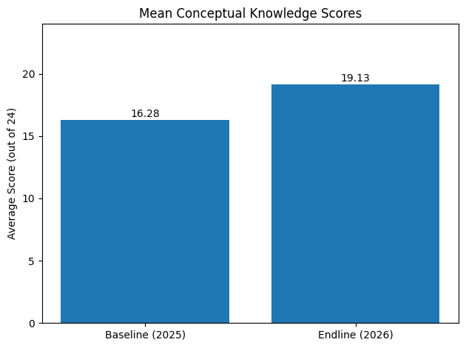
Changes in Learner Performance Distribution
In addition to the increase in average scores, the distribution of learner performance shifted substantially.
At baseline, the majority of learners were located in the weak performance category, while relatively few achieved strong scores. By the endline assessment, a large proportion of learners had moved into the average and strong performance categories, and no learners remained in the very weak category.

Figure 2. Distribution of learner performance categories at baseline and endline.
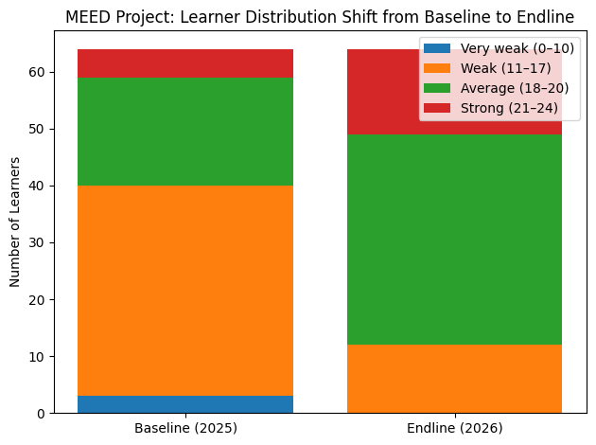
Improvement in School Readiness
The most striking result concerns the proportion of learners reaching the school-readiness threshold.
At baseline, 37.5% of learners scored at or above the readiness threshold. Following programme implementation, this proportion increased to 81.3% of learners.
In practical terms, 28 additional learners in the sample reached the school-readiness threshold after exposure to the programme.

Figure 3. Percentage of learners reaching the school-readiness threshold.
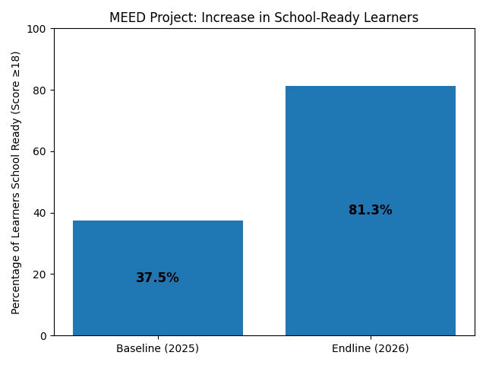

School-Level Results
Improvements were observed across all participating schools, though the magnitude of improvement varied.
Three schools showed substantial gains in average scores, ranging from approximately 3 to 4 points, while one school showed a smaller increase due to a higher starting baseline score. This pattern is consistent with a ceiling effect, where schools beginning with higher initial scores have less room for improvement.
Overall, the consistency of gains across schools suggests that the programme was successfully implemented in multiple contexts.

Additional Endline Results from Solomon Qatyana Primary School
An additional group of learners from Solomon Qatyana Primary School was assessed at endline in 2026. Baseline data was not available for this school; therefore, direct comparison with the baseline cohort was not possible.
However, the endline results from this school can be compared with the other participating schools. Learners at Solomon Qatyana achieved an average score of 20.0, the highest among the assessed schools, and 94% of learners reached the school-readiness threshold.
These results are consistent with, and slightly stronger than, those observed in the other project schools.

Discussion
The findings of this evaluation provide encouraging evidence regarding the impact of the Basic Concepts Programme on learners’ conceptual readiness for formal learning.
Several aspects of the results are noteworthy. First, the magnitude of improvement in average scores represents a large educational effect according to conventional research standards. Second, the distribution of learner performance shifted significantly, indicating that gains were not limited to a small number of high-performing learners but occurred across the cohort.
Third, the proportion of learners reaching the school-readiness threshold more than doubled following programme implementation. This finding is particularly significant because conceptual readiness is closely associated with later success in literacy and numeracy learning.
The observed gains are consistent with the theoretical framework of Feuerstein’s Mediated Learning Experience, which emphasises the role of intentional mediation in developing learners’ cognitive structures and conceptual understanding. By systematically mediating fundamental concepts in the classroom, teachers may enable learners to construct the conceptual frameworks necessary for effective learning.
It is important to note that the study involved a relatively modest sample size and did not include external control schools. Nevertheless, the large effect size, the consistency of results across multiple schools, and the alignment with the programme’s theoretical framework provide promising evidence of the programme’s impact.

Conclusion
The results of this evaluation suggest that systematic mediation of foundational concepts through the Basic Concepts Programme can significantly improve learners’ conceptual readiness for formal schooling.
Within one year of programme implementation, learners demonstrated substantial improvements in conceptual knowledge and a marked increase in the proportion of learners reaching the school-readiness threshold.
These findings support the continued implementation and further evaluation of the programme as a promising approach to strengthening the cognitive and conceptual foundations of learning in the early years of schooling.

