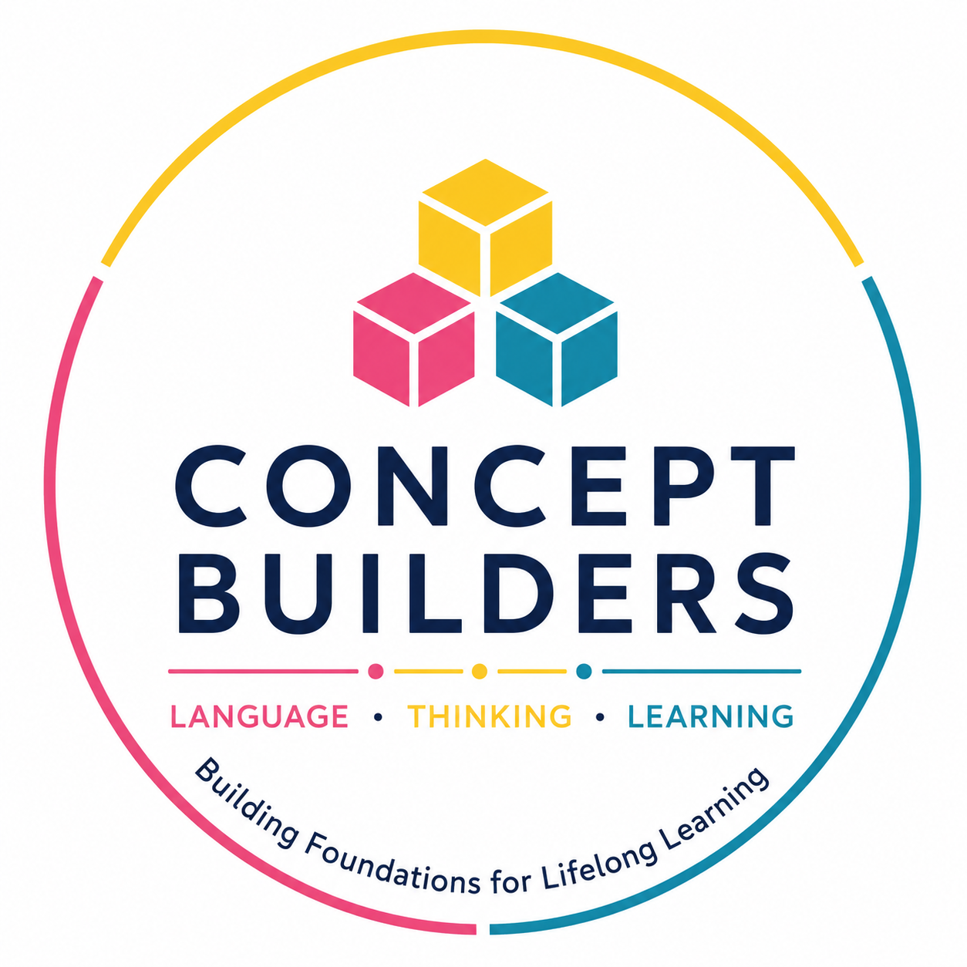
CONCEPT BUILDERS
HOLY CROSS
Programme Dates | August – October 2026
Two Concept Builders groups will be running at Holy Cross:
Grade 1 learners • Grade 2–3 learners
Both groups will follow the programme on the dates below.
Month | Session | Dates
August | 1 | 17 & 19 August
August | 2 | 24 & 26 August
August / September | 3 | 31 August & 2 September
September | 4 | 7 & 9 September
September | 5 | 14 & 16 September
October | 6 | 5 & 7 October
October | 7 | 12 & 14 October
October | 8 | 19 & 21 October

LANGUAGE • THINKING • LEARNING
Building foundations for lifelong learning

