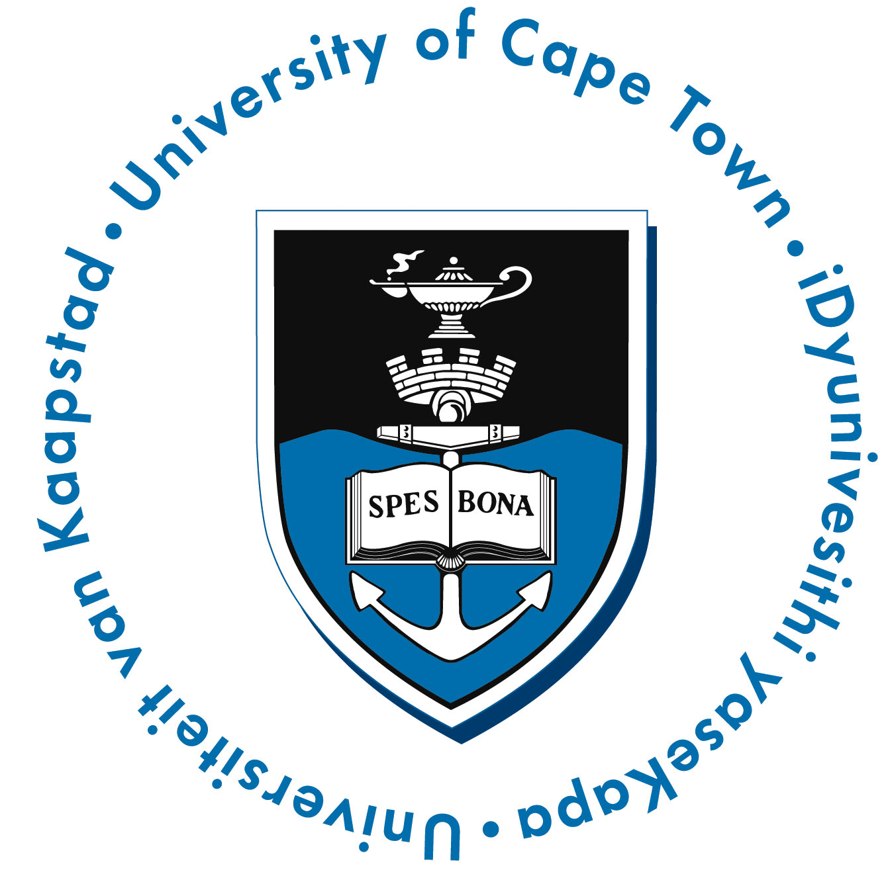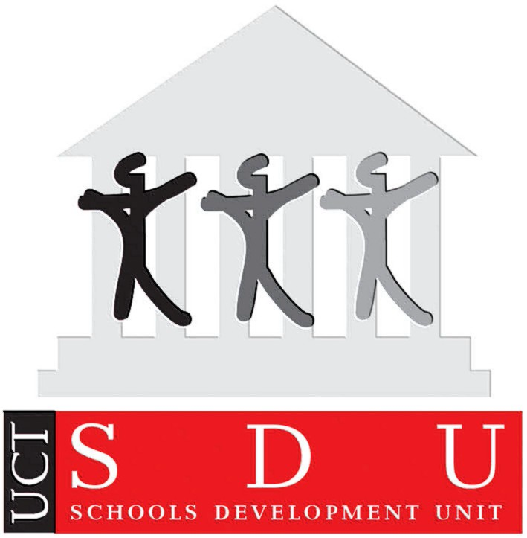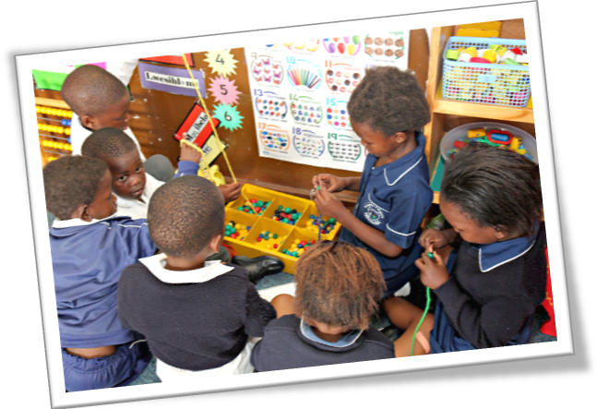

14.30 – 16.00

Cape Teaching and Leadership Institute (CTLI)
Nooiensfontein Road, Kuils River

Refreshments will be served at 14.30

  - 23 January 2013

Special Thanks

Teachers and Principals from the iKwezi schools

Western Cape Education Department (WCED)

Metropole East & North Education Districts

The DG Murray Trust

iKwezi Project Team

Programme

Welcome

Ms Ursula Esau

Address

Dr John Clark

Educator Response

MsMandisaYamiso

Presentation of Certificates

Basic Concepts Programme: Dr Louis Benjamin

Early Learning Resources Unit (ELRU): Ms Blossom Ngwevela

Schools Development Unit: Ms Tami Mhlati

Thanks

(MsDiane Hendricks)

iKwezi Project

Certification Ceremony

Grade R and 1

